Project title: Student Result and Performance Analyzer Using Java
1. Aim
To develop a Student Result and Performance Analyzer using Java to calculate students' total marks, percentage, grades, pass/fail status, and overall academic performance.
2. System Requirements
Hardware requirements
- Processor: Intel i3 or equivalent
- RAM: Minimum 4 GB
- Storage: Minimum 500 MB free space
Software requirements
- Operating System: Windows/Linux
- Java Development Kit (JDK 21 or compatible version)
- IDE: Eclipse, IntelliJ IDEA, or an online Java compiler
- Command Prompt/Terminal or online compiler execution environment
3. Algorithm / Logic
- Start the program.
- Read the student's name and roll number.
- Accept marks for five subjects.
- Validate that each subject mark is between 0 and 100.
- Calculate the total marks and percentage.
- Determine whether the student has passed all subjects.
- Assign a grade based on the percentage.
- Display the student's result and performance summary.
- Allow the user to analyze another student's result or exit.
- Stop the program.
4. UML Diagram
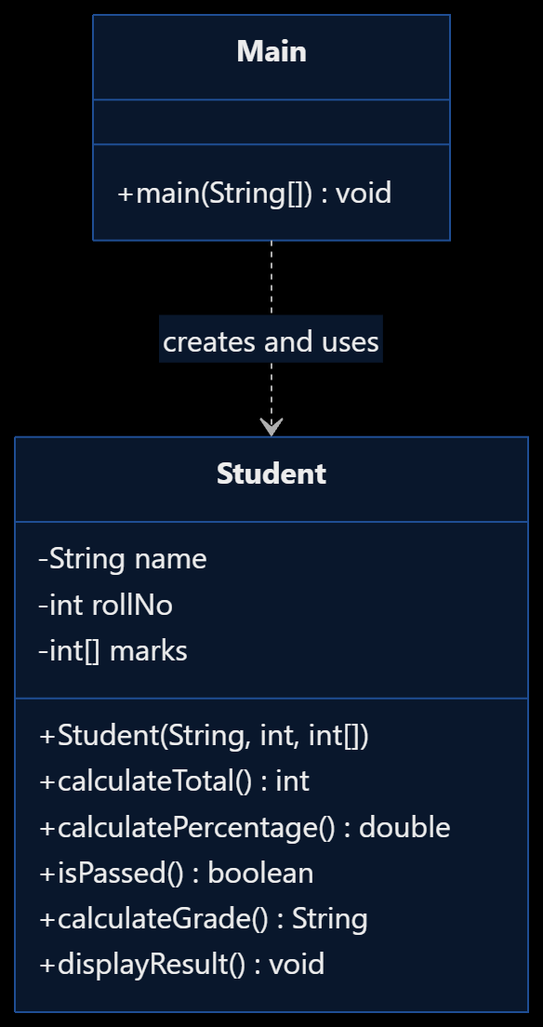
5. Source Code
This version is compatible with online Java compilers that require the main class to be named Main. Copy the entire code into the editor.

import java.util.Scanner;

class Student {
private String name;
private int rollNo;
private int[] marks;

Student(String name, int rollNo, int[] marks) {
this.name = name;
this.rollNo = rollNo;
this.marks = marks.clone();
}

public int calculateTotal() {
int total = 0;
for (int mark : marks) {
total += mark;
}
return total;
}

public double calculatePercentage() {
return calculateTotal() / (double) marks.length;
}

public boolean isPassed() {
for (int mark : marks) {
if (mark < 35) {
return false;
}
}
return true;
}

public String calculateGrade() {
if (!isPassed()) {
return "F";
}

double percentage = calculatePercentage();

if (percentage >= 90) return "A+";
if (percentage >= 80) return "A";
if (percentage >= 70) return "B";
if (percentage >= 60) return "C";
if (percentage >= 50) return "D";
return "P";
}

public void displayResult() {
System.out.println("\n===== STUDENT RESULT =====");
System.out.println("Name: " + name);
System.out.println("Roll Number: " + rollNo);

System.out.println("\nSubject-wise Marks:");
for (int i = 0; i < marks.length; i++) {
System.out.println("Subject " + (i + 1) + ": " + marks[i]);
}

System.out.println("Total Marks: " + calculateTotal()
+ " / " + (marks.length * 100));

System.out.printf("Percentage: %.2f%%%n",
calculatePercentage());

System.out.println("Result: " +
(isPassed() ? "PASS" : "FAIL"));
System.out.println("Grade: " + calculateGrade());

if (isPassed()) {
System.out.println("Performance: " +
getPerformance(calculatePercentage()));
} else {
System.out.println(
"Performance: Needs Improvement");
}
}

private String getPerformance(double percentage) {
if (percentage >= 90) return "Excellent";
if (percentage >= 80) return "Very Good";
if (percentage >= 70) return "Good";
if (percentage >= 60) return "Satisfactory";
if (percentage >= 50) return "Average";
return "Pass";
}
}

public class Main {
public static void main(String[] args) {
Scanner sc = new Scanner(System.in);
String again;

do {
try {
System.out.println(
"\nSTUDENT RESULT AND PERFORMANCE ANALYZER");

System.out.print("Enter student name: ");
String name = sc.nextLine().trim();

if (name.isEmpty()) {
System.out.println("Name cannot be empty.");
continue;
}

System.out.print("Enter roll number: ");
int rollNo = Integer.parseInt(sc.nextLine());

if (rollNo <= 0) {
System.out.println(
"Roll number must be positive.");
continue;
}

int[] marks = new int[5];

for (int i = 0; i < marks.length; i++) {
System.out.print(
"Enter marks for subject " + (i + 1)
+ " (0-100): ");

marks[i] = Integer.parseInt(sc.nextLine());

if (marks[i] < 0 || marks[i] > 100) {
throw new IllegalArgumentException(
"Marks must be between 0 and 100.");
}
}

Student student =
new Student(name, rollNo, marks);

student.displayResult();

} catch (NumberFormatException e) {
System.out.println(
"Error: Please enter valid whole numbers.");

} catch (IllegalArgumentException e) {
System.out.println("Error: " + e.getMessage());
}

System.out.print(
"\nAnalyze another student? (yes/no): ");
again = sc.nextLine().trim();

} while (again.equalsIgnoreCase("yes"));

System.out.println("Program terminated.");
sc.close();
}
}
6. Compilation and Execution
For an online Java compiler:
- Select Java as the programming language.
- Replace the default code with the program above.
- Make one small correction before running: change
String again;
to
String again = "yes";
This ensures the program compiles correctly when validation uses continue.
- Click Run and enter the input when prompted.
7. Sample Output Screen

STUDENT RESULT AND PERFORMANCE ANALYZER
Enter student name: Gayatri
Enter roll number: 101
Enter marks for subject 1 (0-100): 95
Enter marks for subject 2 (0-100): 88
Enter marks for subject 3 (0-100): 92
Enter marks for subject 4 (0-100): 85
Enter marks for subject 5 (0-100): 90

===== STUDENT RESULT =====
Name: Gayatri
Roll Number: 101

Subject-wise Marks:
Subject 1: 95
Subject 2: 88
Subject 3: 92
Subject 4: 85
Subject 5: 90
Total Marks: 450 / 500
Percentage: 90.00%
Result: PASS
Grade: A+
Performance: Excellent

Analyze another student? (yes/no): no
Program terminated.
8. output
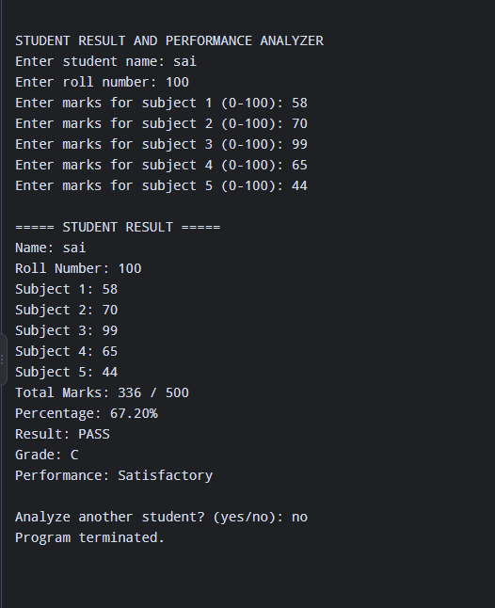
Result
Thus, the Student Result and Performance Analyzer was implemented successfully using Java. The program calculates total marks, percentage, grades, pass/fail status, and performance level while demonstrating classes, objects, encapsulation, arrays, loops, conditional statements, and exception handling.

